Paper Title
Author¹, Author², Author³, Author⁴
Author Affiliation Line1
Author Affiliation Line2
email¹, email², email³, email⁴

Abstract – A concise and factual abstract is required (between 200 - 250 words). The abstract should state briefly the purpose of the research, the principal results and major conclusions. It should be bold Italic. The whole manuscript except the title must follow the Times New Roman Font Style with 11 font size and single spaced. The title of the article must be written in both small and capital letters with first letter of the word capital, using font size 14 and bold. The 8.5” x 11” is the size of the paper to be used with margin of 1” in all sides. The name and surname of the author(s), their title, and the affiliation they work for and email must be written. This provides the researchers a general template in preparation of the research paper for publication in APJARSS.
Keywords – Provide 3-5 keywords or phrases in alphabetical order, separated by commas.

Introduction
The introduction must include the rationale and the main objectives with proper discussion of the variables as well as the significance of the study. This also includes the arguments and citation of related literature and studies. Provide crisp and easy to read content. The article should be readable by a normal user. Do not write complex sentences, multiple sentences for expressing same content, quality of the article is directly proportional to the English used, and the way it handles transition. Use simple expressions, properly convey the content within short sentences and focus on making the reader understand the concept quickly. Curtail to the minimum number of words, the full article may be completed within 3,000-5,000 words. Use high quality references using refereed journals that match the content quality, use the details in the reference and properly cite them.
Define abbreviations and acronyms the first time they are used in the text, even after they have already been defined in the abstract.
Number citations consecutively in square brackets [1]. The sentence punctuation follows the brackets [2]. Multiple references [2], [3] are each numbered with separate brackets [1]–[3]. When citing a section in a book, please give the relevant page numbers [2]. In sentences, refer simply to the reference number, as in [3]. Do not use “Ref. [3]” or “reference [3]” except at the beginning of a sentence: “Surname of Author [3] shows ... .” Please ensure that every reference cited in the text is also present in the reference list. Arrange the reference section in order of citation appearance. Use the common format, Author(s) name., year of publication., Article title, Journal name, Volume(issue), page numbers, Doi. Do not give year in the last and give it only after the author name, do not use the word Volume and Issue anywhere use only volume and issue numbers like 2(3), 23-87. Please note that the references at the end of this document are in the preferred referencing style. Give all authors’ names; do not use “et al.” This section may vary according to the sequence and prescribed format by a certain international journal publication. If the research paper of students/faculty members may be accepted in any internal journal publication, only few modifications will be done on the reference section to follow the prescribed format. The most important point here is the complete information of the citation.

Objectives of the Study
State the general and specific objectives or purpose of conducting the study in paragraph format.
Materials and Methods
Describe the research method used in the study. Discuss comprehensively the sampling technique used in selecting the participants if the study will not use the total population. It is very important to explain the generation and validation of instrument. If the questionnaire or any data gathering instrument used is not standardized, explain further the reliability tests or validation procedures have done in the instrument. The Data Collection Procedure must also be well defined. The statistical tools used in the study must be well explained in the Data Analysis part. Ethical Considerations (if applicable) is also considered important in informing the participants regarding the purpose of the administration of the instrument or the main purpose of the study. Included here is the proper way of putting sub-headings and its levels.
Sub-Heading
Paragraph Paragraph Paragraph Paragraph Paragraph Paragraph Paragraph Paragraph Paragraph Paragraph Paragraph Paragraph Paragraph Paragraph Paragraph Paragraph Paragraph Paragraph Paragraph Paragraph Paragraph Paragraph Paragraph Paragraph Paragraph Paragraph Paragraph Paragraph Paragraph Paragraph Paragraph Paragraph Paragraph Paragraph.
Sub-Heading
Paragraph Paragraph Paragraph Paragraph Paragraph Paragraph Paragraph Paragraph Paragraph Paragraph Paragraph Paragraph Paragraph Paragraph Paragraph Paragraph Paragraph Paragraph Paragraph Paragraph Paragraph Paragraph Paragraph Paragraph Paragraph Paragraph Paragraph Paragraph Paragraph Paragraph Paragraph Paragraph Paragraph Paragraph Paragraph Paragraph Paragraph Paragraph Paragraph Paragraph Paragraph Paragraph Paragraph Paragraph Paragraph Paragraph Paragraph.

Portion under quotation/Poetry etc. Portion under quotation /Poetry etc. Portion under quotation /Poetry etc. Portion under quotation/Pores/Poetry etc d
Results and Discussion
The contents of the journal are peer-reviewed and archival. The international journal publishes scholarly articles of archival value as well as tutorial expositions and critical reviews of classical subjects and topics of current interest. Authors should consider that the technical papers submitted for publication must advance the state of knowledge and must cite relevant prior work. The length of a submitted paper should be commensurate with the importance, or appropriate to the complexity, of the work. For example, an obvious extension of previously published work might not be appropriate for publication or might be adequately treated in just a few pages. Authors must convince both peer reviewers and the editors of the scientific and technical merit of a paper; the standards of proof are higher when extraordinary or unexpected results are reported.
Because replication is required for scientific progress, papers submitted for publication must provide sufficient information to allow readers to perform similar experiments or calculations and use the reported results. Although not everything need be disclosed, a paper must contain new, useable, and fully described information.

Table 1. The Arrangement of Channels
Channels | Group 1 | Group 2 | … | Group c
Main channel | Channel 1 | Channel 2 | … | Channel c
Assistant channel | Channel 2 | Channel 3 | … | Channel 1

Tables should follow the institutional format and keep it simple and minimum in number. In tables font size 11 must be used and vertical lines must not be drawn. When the contents of the table cannot fit into the table, font size 10 might be used. Number of the table and the title should be written above the table. Tables (eg, Table 1) are also numbered consecutively, 1, 2, etc., from start to finish of the paper, ignoring sections and subsections, and independently from figures.
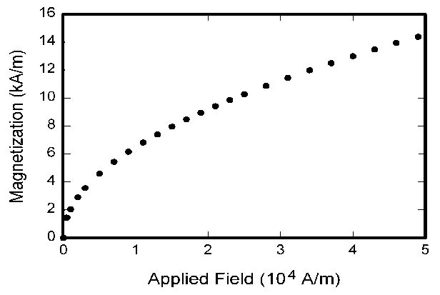
Fig. 1. Magnetization as a function of applied field.

Figures should be designated with Arabic numerals and upper case letters for their parts (Figure 1). Each legend should begin with a title and should be sufficiently described so that without reading the text, figure should be understandable. All figures, tables, etc. must have a caption, centre-justified. Tables and figures should appear as close to their point of reference as satisfactory formatting of the final document permits.
Conclusion and Recommendation
A conclusion may review the main points of the paper, do not replicate the abstract as the conclusion. A conclusion might elaborate on the importance of the work or suggest applications and extensions.
Appendix
Appendixes, if needed, appear before the references.
References
Strictly follow the numbered format of citation while observing the proper APA style of referencing.
- Author Name (s). (Year). Title of the Paper/Article, Journal Name, Volume (Number), pp. (Printed Pages i.e. pp. 45-51)
- Author Name (s). (Year). Title of the Book, Edition, Publisher, pp. (Printed Pages i.e. pp. 45-51)
- Author Name (s). (Year). Title of the Technical Report, Publisher, pp. (Printed Pages i.e. pp. 45-51)
- For online article: Author Name (if any), Title of the Article, URL: (i.e. http://psychology.about.com/od/apastyle/ig/APA-Format-Examples/references.htm), date retrieved:
- Author Name (s), Title of the Paper/Article, Proceedings of <Name of the conference>, Date & Year, Place & Country, Volume No. pp. (Printed Pages i.e. pp. 45-51)

